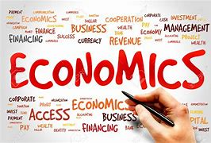

Phase 3 Bridging Task for A-level Economics
2023/2024

Course outline with key assessment dates

The specification can be accessed here (Edexcel A Specification):

Edexcel AS and A level Economics A 2015 | Pearson qualifications

All assessment for the course is completed in Year 13, with three examinations in the Summer term.

A-Level Subject content:

The Pearson Edexcel Level 3 Advanced GCE in Economics A is structured into four themes and consists of three externally examined papers. Students build knowledge and understanding of core economic models and concepts in Themes 1 and 2, and then build on this and apply their knowledge to more complex concepts and models in Themes 3 and 4. Students will need to apply their knowledge and understanding to both familiar and unfamiliar contexts in the assessments and demonstrate an awareness of current economic events and policies.

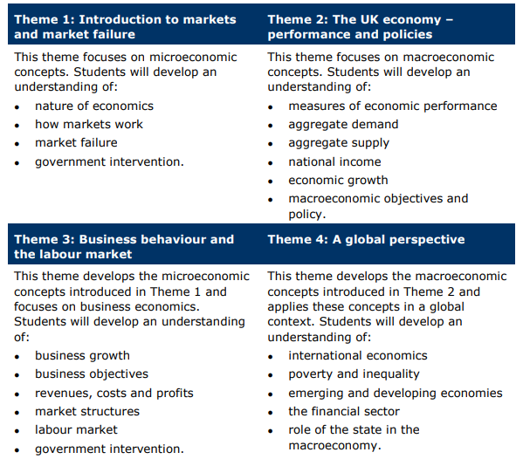

Paper 1 – Markets and Business behaviour |  | Paper 2 – National and Global Economy |  | Paper 3 –  Microeconomics and macroeconomics
What is Assessed  Overview of content Paper 1 will assess microeconomics and questions will be drawn from Themes 1 and 3. |  | What is Assessed  Overview of content Paper 2 will assess macroeconomics and questions will be drawn from Themes 2 and 4. |  | What is Assessed  Paper 3 will assess content across all four themes. Students are required to apply their knowledge and understanding, make connections and transfer higher-order skills across all four themes
Method of Assessment  Written exam; 2 hours  100 marks  2 hours  35 % of A-Level |  | Method of Assessment  Written exam; 2 hours  100 marks  2 hours  35% of A-Level |  | Method of Assessment  Written exam; 2 hours  100 marks  2 hours  30% of A-Level
35% of A Level |  | 35% of A Level |  | 30% of A Level
Questions  Overview of assessment ● Written examination. ● The paper comprises three sections. Students answer all questions from Section A and Section B, and one from Section C. ● Section A comprises a range of multiple-choice and short-answer questions. ● Section B comprises one data response question broken down into a number of parts. ● Section C comprises a choice of extended open-response questions; students select one from a choice of two. |  | Questions  Overview of assessment ● Written examination. ● The paper comprises three sections. Students answer all questions from Section A and Section B, and one from Section C. ● Section A comprises a range of multiple-choice and short-answer questions. ● Section B comprises one data response question broken down into a number of parts. ● Section C comprises a choice of extended open-response questions; students select one from a choice of two. ● Duration: 2 hours. ● 100 marks available |  | Questions  Overview of assessment ● Written examination. ● The paper comprises two sections. ● Each section comprises one data response question broken down into a number of parts, including a choice of extended open-response questions; students select one from a choice of two. ● Duration: 2 hours. ● 100 marks available
SUMMER TRANSITION WORK

We are so excited to hear that you are hopefully going to be joining us in September to study A Level Economics.
This booklet will give you a brief introduction to the course layout and help you to start getting to grips with some of the key terminology and content so that we can hit the ground running in September.

The first term will be more knowledge and application focused as to ensure you have a solid foundation and awareness of Economic principles.

The topics we will focus on include:

- Nature of Economics
- How markets work
- Measures of economic performance

We will complete weekly ‘what is in the news’ activities to ensure you are building your awareness and understanding of how Economics applies in the real world.

Please complete the tasks below and bring this completed work with you in September. We have also added some links and information about future Career Pathways in Economics, with links for you to do some research!

Best wishes,

*SUMMER TRANSITION WORK HAND IN WEEK: 11th – 15th SEPTEMBER

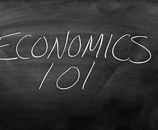Task 1

Research using the links provided and then create a presentation (max 5 slides) explaining what is meant by the 2008 financial crash, what happened in the UK and how it impacted people.

The Financial Crisis…

“In 2008 the world experienced a large economic shock. All major economies around the world suffered a financial crisis and started to go into recession. A lot of economies have struggled to recover from the events of 2008 and are still not experiencing signs of growth”.

Links to research:

Causes of the Global Financial Crisis (Financial Economics) | Economics | tutor2u
https://youtu.be/-dTYz_TIr8Y
The financial crisis - 10 years on (adobe.com)
Witness History - Predicting the financial crash - BBC Sounds
The Market Crash of 2008 Explained | Wealthsimple

Questions to consider:

- How did the financial crisis of 2008 start and why?
- Which major American bank went bankrupt in 2008 and was at the heart of the crisis?
- List three ways the global financial crisis has impacted the UK economy?

Task 2:

Famous Economists

“Adam Smith is the grandfather of Economics. He invented the framework of the way the economy works today. John Maynard Keynes, Milton Friedman and Hayek also have built and added to Smith’s framework of economic theory…”

Questions:
- Research Adam Smit, John Maynard Keynes, Milton Friedman and Hayek and choose 5 key points you have found to create a ‘famous Economist’ poster for each of them

Help on YouTube:

https://www.youtube.com/results?search_query=the+masters+of+money
https://www.youtube.com/results?search_query=adam+smith+documentary&sp=eAE%253D
https://www.youtube.com/results?search_query=john+maynard+keynes&sp=eAE%253D
https://www.youtube.com/results?search_query=milton+friedman+documentary&sp=eAE%253D
https://www.youtube.com/results?search_query=friedrich+hayek

Task 3

Create an Economic Keywords literacy log and ensure you have the definitions and examples where appropriate:

- Inflation
- Economies of Scale
- GDP
- Merit Goods
- Balance of Payments
- Demerit Goods
- Public goods
- Public sector
- Monopoly power
- Structural unemployment
- Cyclical unemployment
- Fiscal policy
- Inferior good
- Monetary policy
- Supply side policy
- Tax
- Interest rates

Some websites to help with your research:

- Definitions A-Z from the economist http://www.economist.com/economics-a-to-z
- Tutor2u – research any economic topic or event http://beta.tutor2u.net/economics/topics
- Economics online http://www.economicsonline.co.uk/

Task 4:

Listen and then write a two-page summary explaining your understanding of the economy using information from the links:

Understand - The Economy - Welcome to Understand: The Economy - BBC Sounds
Understand - The Economy - The Economy: 1. Inflation - BBC Sounds
Understand - The Economy - The Economy: 2. Interest Rates and Mortgage Rates - BBC Sounds

Task 5:

Read the article below and write a half page summary explaining the changes in Interest rates and impact on millennials and the economy.

Avoid avocado toast. Ditch the flat white. And turn your back on the lure of Instagrammable holidays. Over the past decade, millennials have been ordered to scrimp, save and toil to get on the property ladder. Cutting out small luxuries won’t have helped much in the pursuit of home ownership. But for those who managed to buy a home in recent years, there is a fresh insult.
In Britain’s exploding mortgage timebomb, young adults are paying the heaviest price – exposing yet again Britain’s widening generational gulf. As the Bank of England whacks up interest rates to save the nation from the highest inflation rates since the early 1980s, it is those who hadn’t even been born then who carry the heaviest burden for bringing it down.
According to the Institute for Fiscal Studies, the increase in monthly mortgage payments awaiting 20- to 40-year-olds will be about twice as large as the rise for those over the age of 60. For millions more who rent, the prospect of home ownership is drifting further from reach, as their (typically older) landlords either sell up, or inflate rents at the fastest rate on record.
As with each of the last three big economic shocks to hit Britain – from the 2008 financial crash to the Covid pandemic and cost of living crisis – the nation’s younger generations have been sold down the river, forced to endure stagnant wages, crumbling job opportunities, the rising cost of education, the dismantling of generous company pension schemes and housing penury. It is hardly any wonder that millennials – broadly defined as those aged 25 to 40 – believe the Tories deserve to lose the next election.
For all the headlines of the past fortnight about mortgage misery and financial pain, it’s worth remembering that a sizeable chunk of society will see little or no impact – having either already paid off their mortgage, or had the wealth or good fortune never to have had one.
More households in England and Wales are in this position than have a mortgage, with as many as 8.1m, or about a third of the total, being mortgage free. Instead, the full force of the Bank’s toughest rate-hiking cycle in decades is reserved for the 7.4m with a mortgage, alongside 5m private renters, and 4.2m social tenants.
In some parts of the country more than half of homes – largely in wealthier rural or suburban areas with older demographics – are owned outright. For north Norfolk, east Devon, the Staffordshire Moorlands and Castle Point in Essex, the exploding mortgage crisis is nowhere near as acute. By comparison, less than a quarter of homes are owned outright in cities such as Liverpool and Newcastle, with the smallest proportions in London, where property prices are highest.
This isn’t to say that older generations will escape entirely, nor that everyone born after 1982 is equally affected. The bank of mum and dad has become a more important route to home ownership than hard work for many, while most under-30s living away from their parents do so in private-rented homes.
However, past episodes of the central bank cranking up interest rates to crush inflation would have had a far more even impact across society. Today, entrenched and worsening inequalities have blunted the power of monetary policy.
Back in 1989, almost 40% of households owned a home with a mortgage, and were therefore exposed to rising costs, according to the Resolution Foundation. Today, as more older people own outright, and more younger adults rent, the share of households with a mortgage is below 30%.
Millennials are half as likely to own a home at the age of 30 as baby boomers were, after a more than tenfold increase in house prices since the early 1980s – leaving the average first-time buyer requiring a deposit 10 times larger than four decades ago.
Older generations might have faced considerably higher interest rates during the inflation-prone 1970s and 80s, when interest rates peaked as high as 17%. But their mortgage costs were still often more affordable than today. Homeowners then benefited from average house prices of below £60,000, about three times annual income, as well as from tax breaks on home loan payments through the government’s now defunct mortgage interest relief at source policy.
https://www.theguardian.com/society/2023/jun/25/margaret-thatchers-dream-turns-to-dust-the-days-of-easy-home-buying-are-over
With house prices averaging £285,000 today, or about eight times the average income, smaller interest rate hikes than in the past will have a more painful impact. In the past decade alone house prices have risen by more than two-thirds, meaning more recent buyers are likely to have larger debts, leaving them severely squeezed.
The good news this time around is that mass home repossessions and the pain of negative equity for millions is unlikely, thanks in part to tougher mortgage regulations introduced since the 2008 financial crisis. However, higher interest rates will add almost £16bn to mortgage payments in aggregate, forcing borrowers to make vast cuts elsewhere to keep a roof over their heads.
For the economy at large, the scale of belt tightening required will probably tip the country into recession. In turn, should more businesses fail, job losses mount and wages stagnate, it will be the working-age population and those just entering the workforce for the first time who face the most hardship.
There is a clear political opportunity. After the parade of economic shocks borne mostly by younger generations, it is time for politicians of all parties to wake up and tackle the yawning divide. Britain’s worsening problem with generational inequality will persist without action.

CAREER PATHWAYS IN ECONOMICS

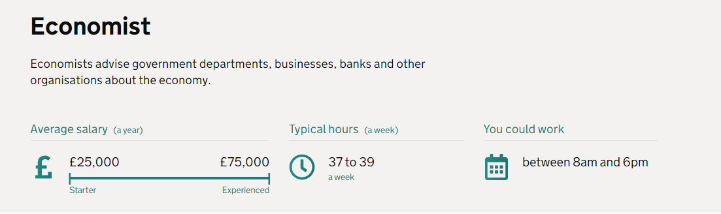

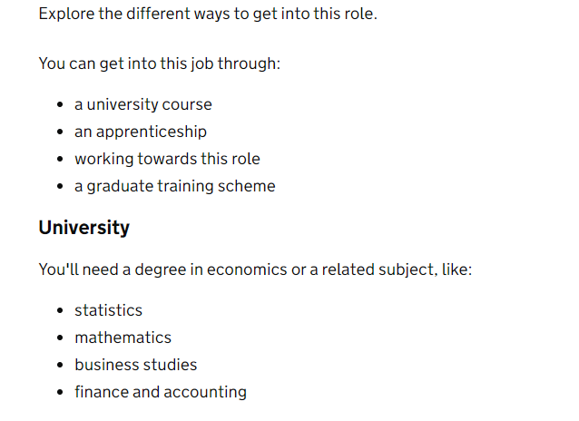
Government Economics fast stream:

Government Economic Service | Civil Service Fast Stream

Careers in Business and banking:

Business and finance | Explore careers (nationalcareers.service.gov.uk)

Key Employer Websites

Explore current opportunities and learn more about recruitment process directly from key employers in Dorset:
- JP Morgan - https://careers.jpmorgan.com/us/en/about-us/locations/bournemouth
- Bupa - https://careers.bupa.co.uk/our-roles
- Ageas - https://www.ageas.co.uk/careers/
- Gattaca - https://www.gattacaplc.com/careers
- Bank of New York Mellon - https://www.bnymellon.com/us/en/careers/index.jsp
- Nationwide Building Society - https://www.nationwide-jobs.co.uk/opportunities/customer-support/contact-centre/bournemouth/
- Barclays International - https://home.barclays/careers/
- LV= Liverpool Victoria - https://www.jobs.lv.com/bournemouth
- Vitality - https://www.vitality.co.uk/careers/

